Unit 3
Physical Layer and its Design Issues

(7 Hours)

3.1 Introduction, Design Issues and Duties of Physical Layer
3.2 Transmission Media: Guided (Twisted Pair, Coaxial Cable, Optical Fiber), Unguided (Radio Wave, Microwave, Infrared and Satellite)
3.3 Ethernet Cable Standards
3.4 Ethernet, Fast-Ethernet and GigaEthernet
3.5 IEEE 802.11 (Wi-Fi) and IEEE 802.15.1(Bluetooth) Standards
3.6 Signals
3.7 Transmission Impairment: Attenuation, Distortion and Noise
3.8 Multiplexing: TDM, FDM and WDM
3.9 Switching: Circuit Switching, Message Switching, Packet Switching, Virtual Circuit Switching
3.10 Network Performance: Bandwidth, Throughput, Latency, Bandwidth-Delay Product, Jitter

3.1 Introduction, Design Issues and Duties of Physical Layer

The Physical Layer is the first and lowest layer of the OSI model.
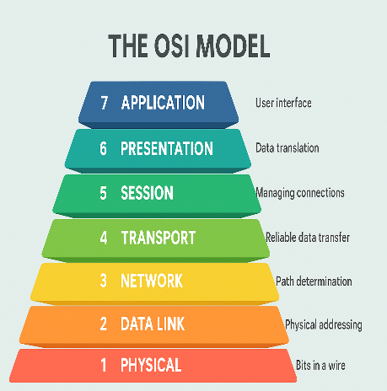
It is responsible for the actual transmission of raw bits from one device to another through a physical medium.
This layer deals with:
- cables
- connectors
- voltage levels
- signals
- data rate
- transmission mode
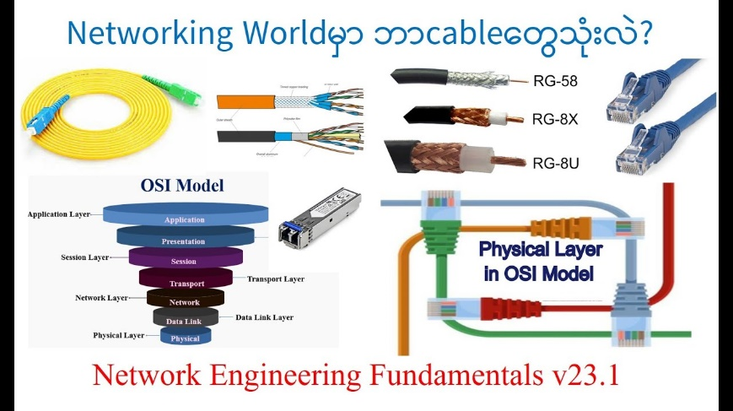
- physical network devices

Simple meaning
If upper layers prepare the data, the physical layer actually puts the bits on the wire or air.

Duties of Physical Layer
The main duties of the physical layer are:
1. Transmission of Raw Bits
It sends 0s and 1s over the communication channel.

2. Representation of Bits
It defines how bits are represented:
- electrical signals
- light pulses
- radio waves

3. Data Rate Control
It specifies how many bits are transmitted per second.

4. Bit Synchronization
It ensures sender and receiver remain synchronized.

5. Line Configuration
It decides whether communication is:
- point-to-point
- multipoint

6. Physical Topology
It supports physical arrangement such as:
- bus
- star
- ring

7. Transmission Mode
It defines:
- simplex
- half-duplex
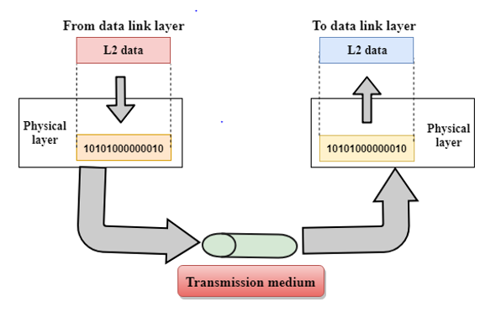
- full-duplex

Design Issues of Physical Layer
Important design issues are:
- how bits should be represented
- how sender and receiver synchronize
- what transmission medium should be used
- how much data rate is supported
- how connectors and interfaces are designed
- how signals travel over long distance
- how to reduce interference and loss

3.2 Transmission Media

Introduction
Transmission media means the path or channel through which data travels from the sender to the receiver.
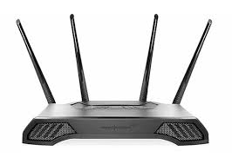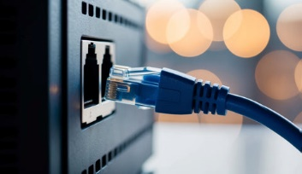
In a communication system, data cannot move by itself. It needs some medium to carry signals.
Example:
- when two computers are connected by cable, the cable is the transmission medium
- when mobile phones communicate wirelessly, air acts as the transmission medium
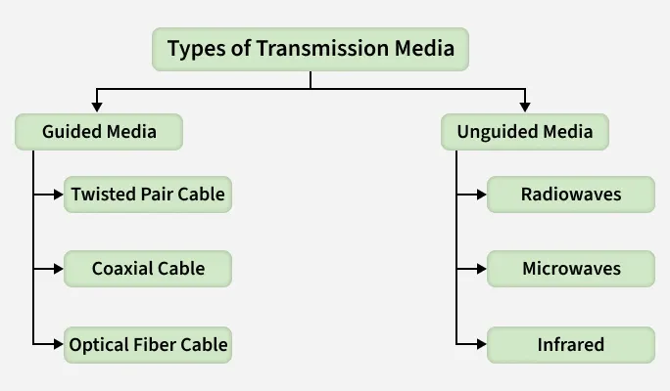
Transmission media are mainly divided into two types:
- Guided Media
- Unguided Media

1. Guided Media
In guided media, signals travel through a physical path.
The signal is guided inside a cable or wire.
Types of Guided Media:
- Twisted Pair Cable
- Coaxial Cable
- Optical Fiber

1.1 Twisted Pair Cable
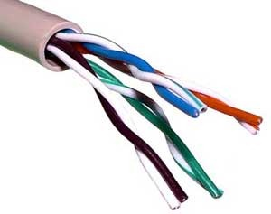
A twisted pair cable consists of two insulated copper wires twisted together.
The twisting helps reduce noise and interference.
Types:
- UTP (Unshielded Twisted Pair)
- STP (Shielded Twisted Pair)
Uses:
- telephone lines
- LAN networks
- Ethernet connections
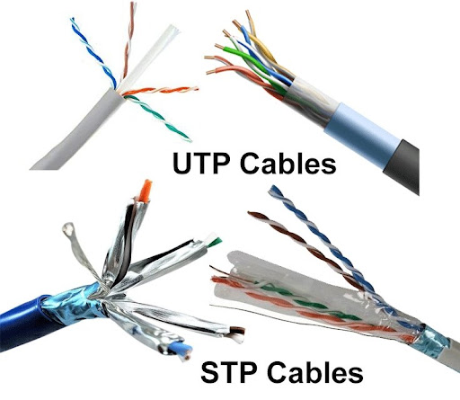
- office networking
Advantages:
- low cost
- easy to install
- flexible
- widely used
Disadvantages:
- limited distance
- more affected by noise than fiber
- lower bandwidth than optical fiber
Example:
In a college computer lab, PCs connected to a switch using LAN cable usually use twisted pair cable.

1.2 Coaxial Cable
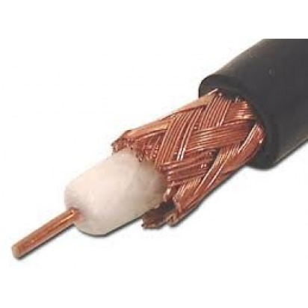
A coaxial cable has:
- one central copper conductor
- insulation layer
- metallic shield
- outer protective cover
It provides better shielding than twisted pair cable.
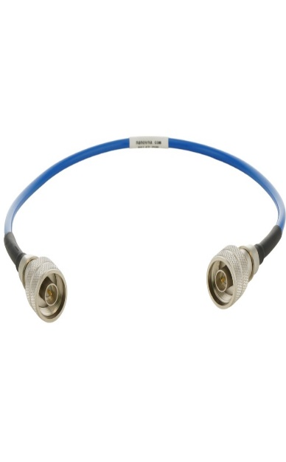
Uses:
- cable television
- CCTV
- broadband internet
- radio communication
Advantages:
- better protection from interference
- higher bandwidth than twisted pair
- stronger and durable
Disadvantages:
- more expensive than twisted pair
- thicker and less flexible
- installation is harder
Example:
Cable TV line entering a home is commonly a coaxial cable.

1.3 Optical Fiber
An optical fiber is a thin strand of glass or plastic that carries data in the form of light signals.
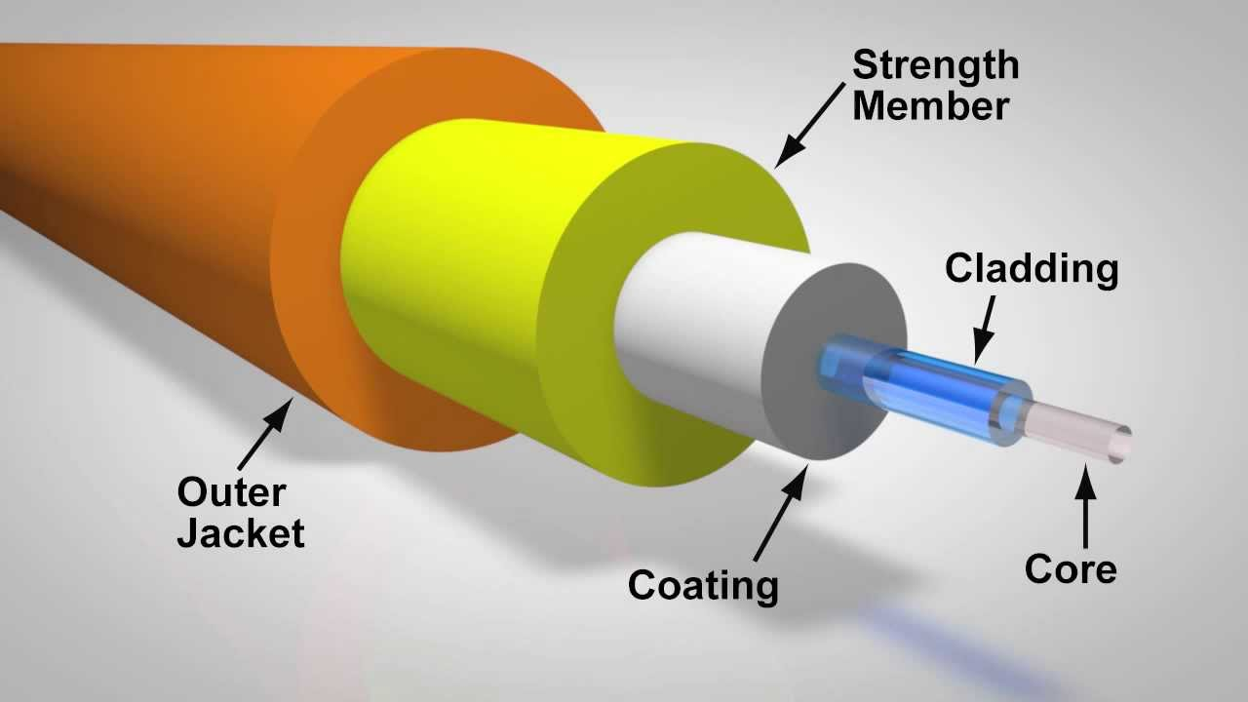
It is the fastest and most secure guided medium.
Types:
- Single-mode fiber
- Multi-mode fiber
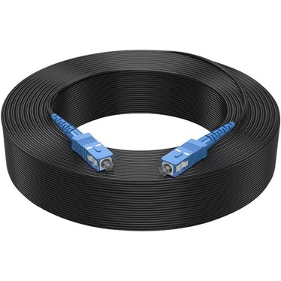
Uses:
- high-speed internet
- backbone networks
- long-distance communication
- telephone networks
Advantages:
- very high bandwidth
- very high speed
- low attenuation
- not affected by electromagnetic interference
- more secure
Disadvantages:
- expensive
- difficult to install
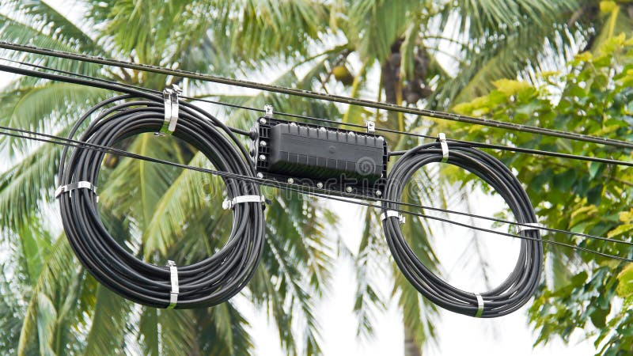
- fragile compared to copper wire
Example:
Internet service providers use optical fiber to connect cities and major networks.

2. Unguided Media
In unguided media, signals travel through air or free space.
No physical cable is required.
These are also called wireless transmission media.
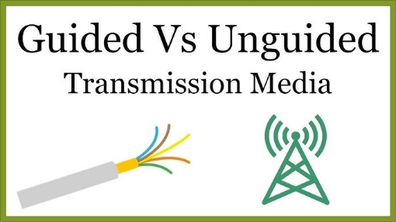
Types of Unguided Media:
- Radio Wave
- Microwave
- Infrared
- Satellite

2.1 Radio Wave
Radio waves are electromagnetic waves used for wireless communication.
They can travel through air and can pass through walls.
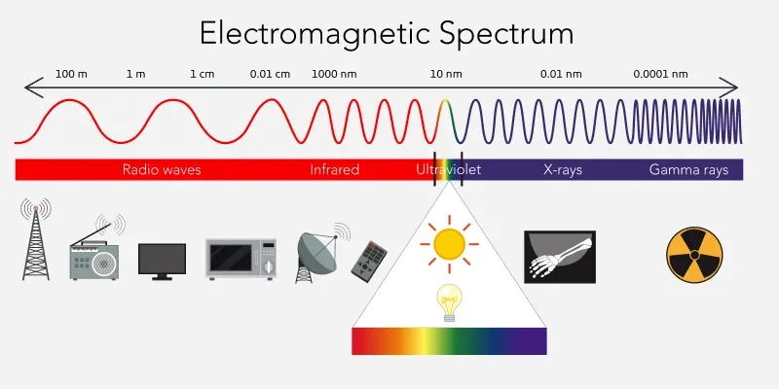
Uses:
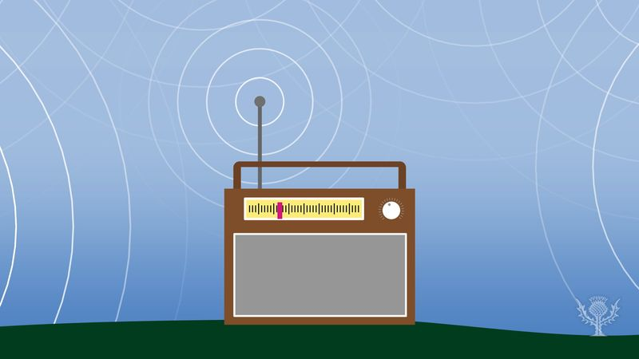
- radio broadcasting
- television broadcasting
- Wi-Fi
- mobile communication
Advantages:
- no wires required
- supports mobility
- can cover large areas
Disadvantages:
- interference possible
- lower security
- quality may be affected by environment
Example:
Wi-Fi in a home uses radio waves.

2.2 Microwave
Microwaves are high-frequency radio waves used for long-distance communication.
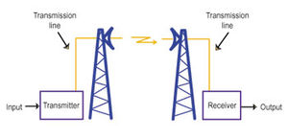
They usually require line-of-sight transmission, meaning there must be a clear path between sender and receiver.
Uses:
- mobile towers
- satellite communication
- long-distance telephone links
- point-to-point communication
Advantages:
- high bandwidth
- good for long-distance communication
- supports large data transfer
Disadvantages:
- affected by weather
- needs line of sight
- installation cost may be high
Example:
Communication between two cell towers often uses microwave links.

2.3 Infrared
Infrared is a short-range wireless medium that uses infrared light waves.

It cannot pass through walls.
Uses:
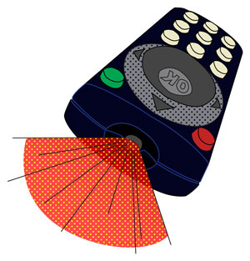
- TV remote control
- short-range device communication
- some wireless peripherals
Advantages:
- simple
- low cost
- secure for room-level communication
Disadvantages:
- very short range
- cannot pass through obstacles
- not suitable for long distance
Example:
A television remote uses infrared signals.

2.4 Satellite
In satellite communication, signals are sent from Earth to a satellite in space and then back to another location on Earth.
It generally uses microwaves.
Uses:
- TV broadcasting
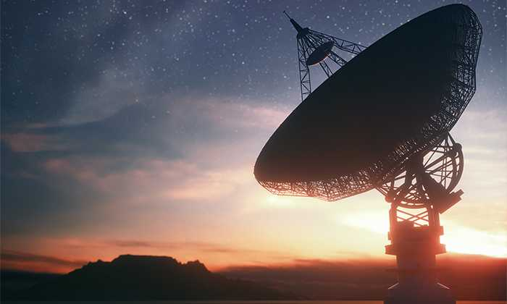
- GPS
- weather monitoring
- internet in remote areas
- military communication
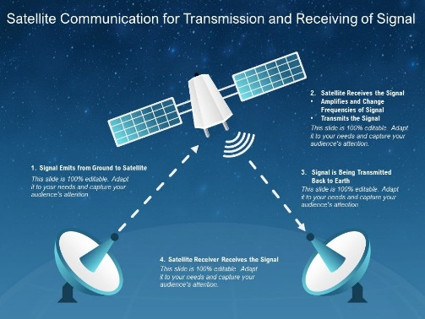
Advantages:
- very wide coverage
- useful in remote and mountainous areas
- supports long-distance communication
Disadvantages:
- expensive
- high latency
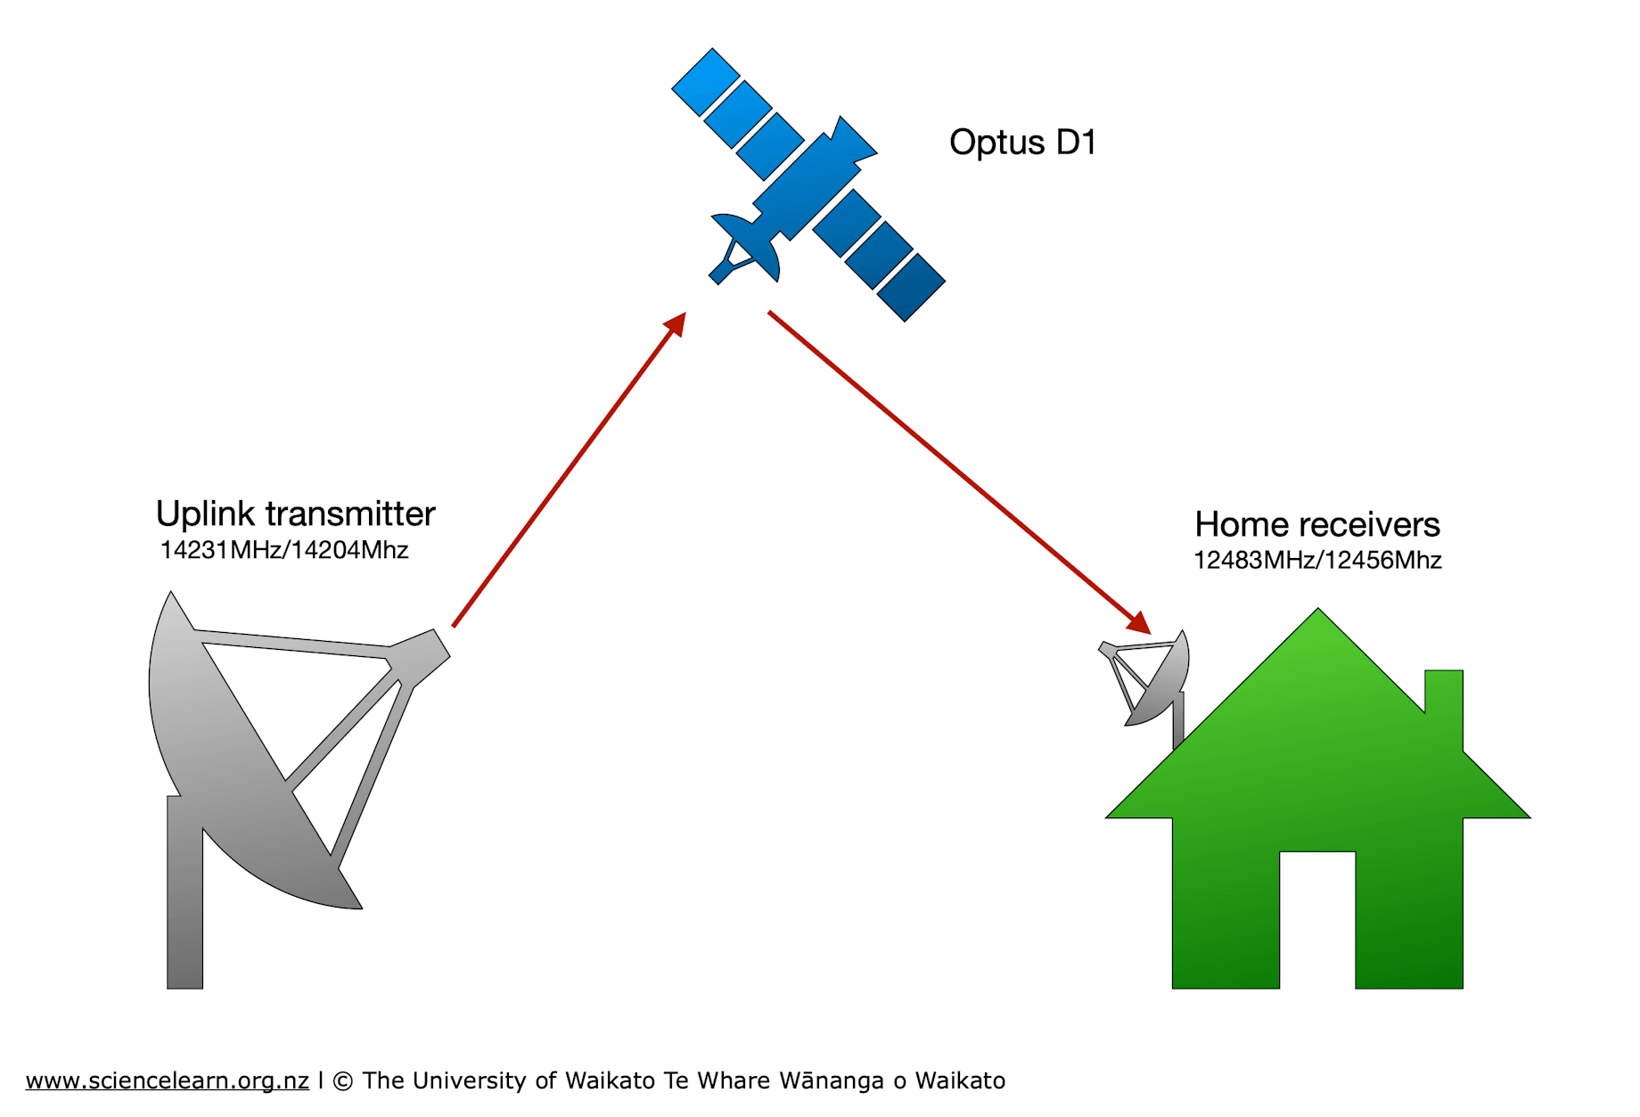
- affected by weather in some cases
Example:
DTH television and global GPS systems use satellites.

3.3 Ethernet Cable Standards

1. Introduction
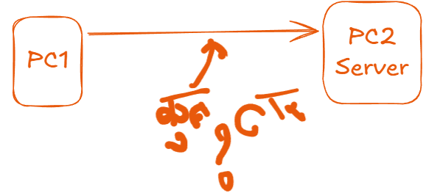
Ethernet cable standards define the proper arrangement of wires inside an Ethernet cable so that devices can communicate correctly in a network.

Ethernet cables are commonly used in:
- LAN
- office networking
- school labs
- home routers and switches
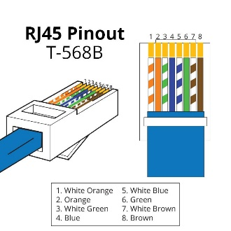
The most common Ethernet cable uses an RJ45 connector with 8 wires.
To make the cable correctly, the wires must follow standard color codes.
The two main standards are:
- T568A
- T568B

1. T568A Standard
In the T568A standard, the 8 wires are arranged in this order:
- White/Green
- Green
- White/Orange
- Blue
- White/Blue
- Orange
- White/Brown
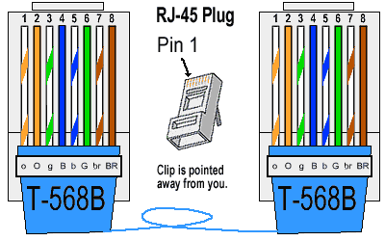
- Brown

2. T568B Standard
In the T568B standard, the 8 wires are arranged in this order:
- White/Orange
- Orange
- White/Green
- Blue
- White/Blue
- Green
- White/Brown
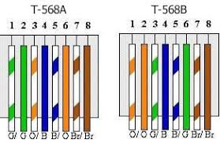
- Brown

3. Why These Standards are Important
Ethernet cable standards are important because they:
- ensure correct communication
- reduce wiring mistakes
- provide compatibility
- help in making standard network cables
- make troubleshooting easier
If the wire arrangement is wrong, the cable may not work properly.

4. Types of Ethernet Cables Based on Standards
A. Straight-Through Cable
A straight-through cable has the same standard on both ends.
Examples:
- T568A to T568A
- T568B to T568B
Uses:
- PC to switch
- PC to hub
- router to switch
Meaning:
The wire order is the same at both ends.

B. Cross-Over Cable
A cross-over cable has different standards on each end.
Example:
- one end = T568A
- other end = T568B
Uses:
- PC to PC
- switch to switch
- hub to hub
(mainly in older networks)
Meaning:
Transmit and receive pairs are crossed.

5. Ethernet Cable Categories
Ethernet cables also come in different categories, which define speed and performance.
Common categories:
- Cat5
- Cat5e
- Cat6
- Cat6a
- Cat7
Short idea:
- higher category = better speed and performance
Example:
- Cat5e supports up to 1 Gbps
- Cat6 supports higher speed and better performance

6. RJ45 Connector

The RJ45 connector is the connector used at the end of Ethernet cable.
It has 8 pins, and each pin connects to one wire of the twisted pair cable.
Use:
It is plugged into:
- NIC
- switch
- router
- hub

7. Simple Example
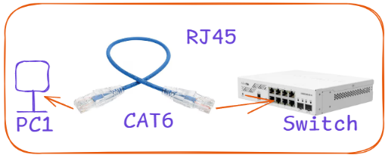
Suppose a student wants to connect a computer to a switch in a lab.
He should usually use a straight-through cable, such as:
- T568B on one end
- T568B on the other end
If he wants to connect one old switch directly to another old switch, he may use a cross-over cable:
- T568A on one end
- T568B on the other end

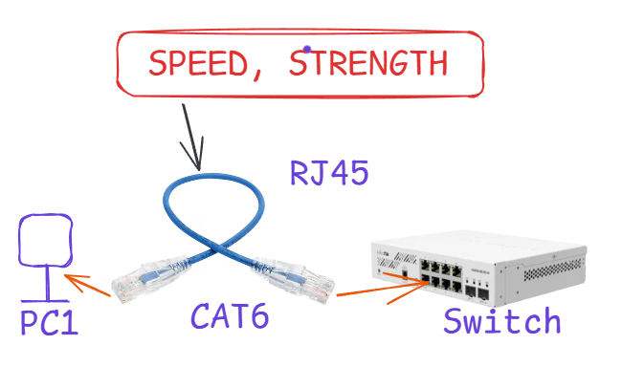
3.4 Ethernet, Fast-Ethernet and GigaEthernet

Ethernet is one of the most widely used technologies in computer networks, especially in LAN (Local Area Network).
It is used to connect:
- computers
- switches
- routers
- printers
- servers
Ethernet defines how data is transmitted in a wired network.
As network demand increased, faster versions of Ethernet were developed:
- Ethernet
- Fast Ethernet
- Gigabit Ethernet
The main difference among them is speed.
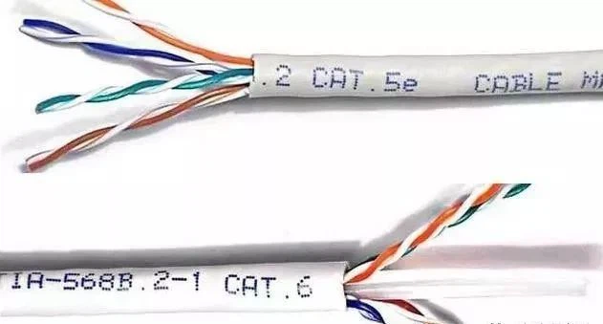
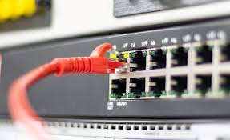
1. Ethernet
The original Ethernet provides a speed of:
10 Mbps
(10 megabits per second)
It is the basic form of Ethernet used in early LANs.
Features:
- speed = 10 Mbps
- used in small or older networks
- suitable for basic data transfer
Example:
Older office computers connected in a LAN with 10 Mbps speed.
Limitation:
As internet use, file transfer, and multimedia increased, 10 Mbps became too slow.

2. Fast Ethernet
Fast Ethernet is an improved version of Ethernet.
It provides a speed of:
100 Mbps
(100 megabits per second)
This is 10 times faster than traditional Ethernet.
Features:
- speed = 100 Mbps
- better for office networks
- supports larger data transfer
- widely used in many LANs
Example:
A school computer lab where many computers share files and internet.
Advantage over Ethernet:
It reduces transfer time and improves performance.

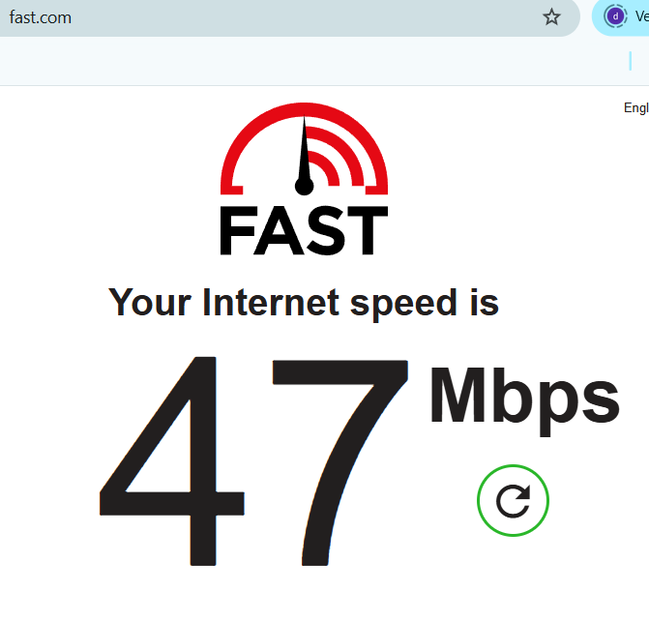
3. Gigabit Ethernet
Gigabit Ethernet is a much faster version of Ethernet.
It provides a speed of:
1000 Mbps = 1 Gbps
(1 gigabit per second)
This is:
- 100 times faster than Ethernet
- 10 times faster than Fast Ethernet
Features:
- speed = 1 Gbps
- used in modern LANs
- suitable for high-speed communication
- supports video, server connection, large file transfer
Example:
Modern colleges, data centers, offices, and backbone LAN connections often use Gigabit Ethernet.
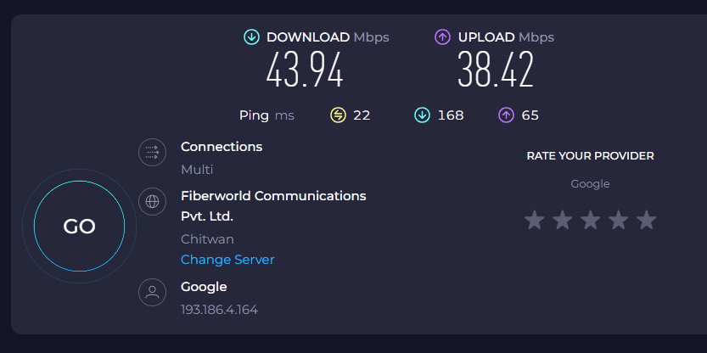
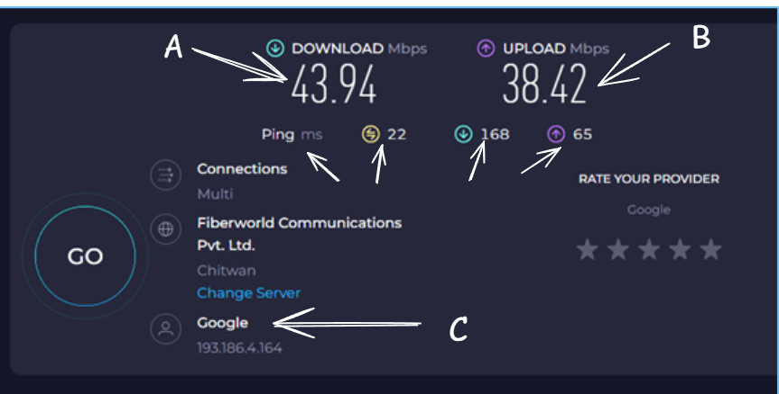
4. Simple Speed Comparison
Type | Speed
Ethernet | 10 Mbps
Fast Ethernet | 100 Mbps
Gigabit Ethernet | 1000 Mbps or 1 Gbps

5. Easy Analogy
Imagine three roads for vehicles:
- Ethernet = narrow road
- Fast Ethernet = wider road
- Gigabit Ethernet = highway
The wider the road, the more vehicles can pass quickly.
In the same way:
- higher Ethernet speed means more data can travel in less time

3.5 IEEE 802.11 (Wi-Fi) and IEEE 802.15.1(Bluetooth) Standards

Introduction

IEEE is an international organization that develops standards for networking and communication technologies.
In computer networks, different wireless technologies follow different IEEE standards.
Two important wireless standards are:
- IEEE 802.11 for Wi-Fi
- IEEE 802.15.1 for Bluetooth
These standards define how wireless devices communicate with each other.
1. IEEE 802.11 (Wi-Fi)
IEEE 802.11 is the standard used for wireless local area network (WLAN), commonly known as Wi-Fi.
Wi-Fi allows devices to connect to a network or the internet without using cables.
Common devices using Wi-Fi:
- laptop
- smartphone
- tablet
- smart TV
- printer
Main features of Wi-Fi:
- wireless communication
- medium to high range
- high data transfer speed
- used for internet access
- used in homes, offices, schools, colleges, and public places
Uses of Wi-Fi:
- connecting mobile and laptop to internet
- wireless office networking
- smart home devices
- wireless campus network
Example:
When a student connects a laptop to the college router without cable, that is Wi-Fi communication under IEEE 802.11.

2. IEEE 802.15.1 (Bluetooth)
IEEE 802.15.1 is the standard used for Bluetooth communication.
Bluetooth is used for short-range wireless personal communication.
It is mainly used to connect nearby devices directly.
Common devices using Bluetooth:
- mobile phone
- wireless headphones
- speaker
- keyboard
- mouse
- smartwatch
Main features of Bluetooth:
- short-range communication
- low power consumption
- used for personal area network (PAN)
- device-to-device connection
- does not need internet for direct pairing
Uses of Bluetooth:
- mobile to headphone connection
- file sharing between two phones
- wireless mouse and keyboard connection
- smartwatch pairing
Example:
When a person connects a Bluetooth earbud to a mobile phone, that communication follows IEEE 802.15.1 standard.

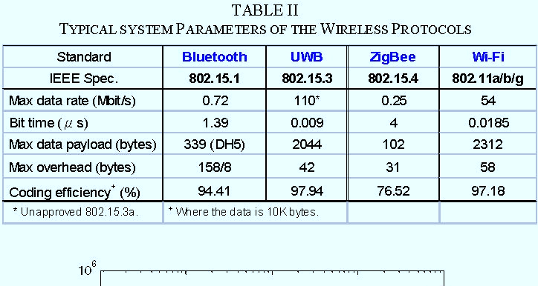
3. Difference Between Wi-Fi and Bluetooth
Basis | Wi-Fi (IEEE 802.11) | Bluetooth (IEEE 802.15.1)
Full form | Wireless LAN | Wireless Personal Area Network
Range | Larger | Shorter
Speed | Higher | Lower
Power consumption | More | Less
Main use | Internet and network access | Device-to-device connection
Example | Laptop connected to router | Phone connected to headset

4. Simple Analogy
Think of:
- Wi-Fi like a school bus that carries many students over a longer distance
- Bluetooth like a bicycle for short personal travel
This means:
- Wi-Fi connects devices over a wider area and carries more data
- Bluetooth is for short-distance personal use

5. Simple Examples
Example of Wi-Fi
In a college:
- one wireless router is installed
- students connect laptops and phones
- all devices access internet without cable
This is IEEE 802.11 Wi-Fi
Example of Bluetooth
A teacher connects:
- phone to wireless speaker
- laptop to Bluetooth mouse
This is IEEE 802.15.1 Bluetooth

6. Benefits of Wi-Fi
- no cable needed
- easy internet access
- mobility
- can connect many devices
- useful in office, home, campus

7. Benefits of Bluetooth
- simple short-range connection
- low power use
- easy pairing
- useful for personal devices
- no cable required

3.6 Signals

A signal is an electrical, optical, or electromagnetic form of data that carries information from one place to another. 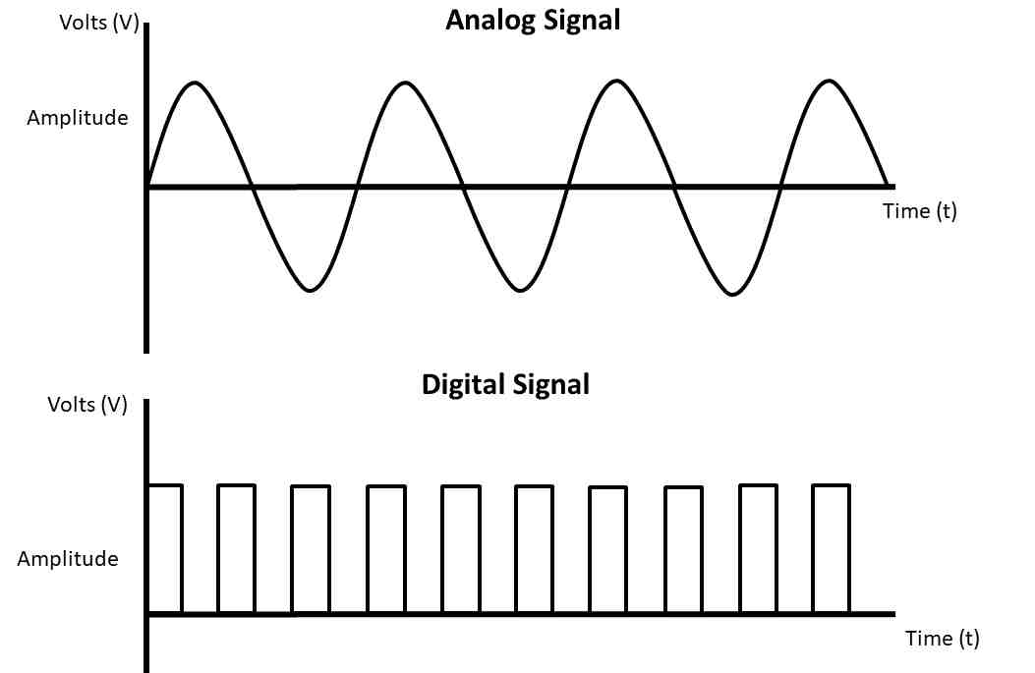
In communication systems, data cannot travel directly. It is first converted into a signal, and then that signal is transmitted through a medium.
Simple meaning
A signal is the representation of data used for communication.
Example:
- human voice converted into electrical signal in telephone
- Wi-Fi data sent as radio signal
- optical fiber data sent as light signal

1. Why Signals are Needed
....................................
Signals are needed because:
- data must be transmitted from sender to receiver
- communication devices understand signal form
- information can travel through cable or air only in signal form
Without signals, communication is not possible.

2. Types of Signals
Signals are mainly of two types:
- Analog Signal
- Digital Signal

2.1 Analog Signal
An analog signal is a continuous signal that changes smoothly with time.
It can take infinite values within a range.
Characteristics:
- continuous in time
- continuous in amplitude
- smooth waveform
- more affected by noise
Example:
- human voice
- temperature signal
- radio broadcast
- old telephone signal
Shape:
Usually shown as a smooth sine wave.
Simple example:
When a person speaks into a microphone, the sound wave produced is analog.
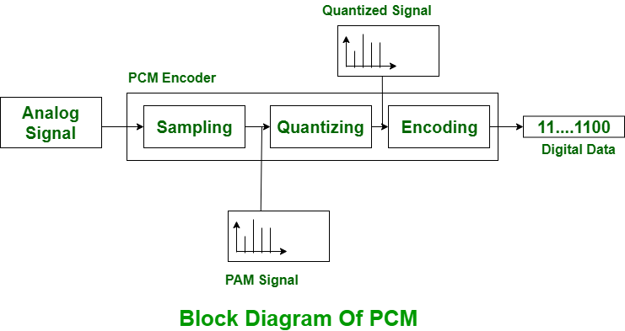

2.2 Digital Signal
A digital signal is a discrete signal that has a limited number of values, usually 0 and 1.
Characteristics:
- discrete in nature
- represented by binary values
- less affected by noise
- easy to store and process
Example:
- computer data
- digital clock signal
- binary transmission in networks
Shape:
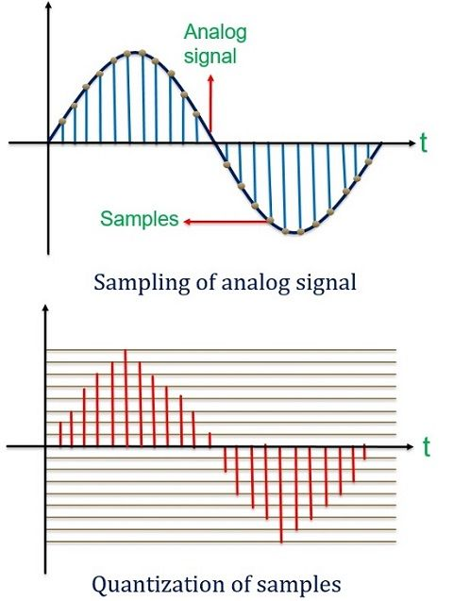
Usually shown as square pulses.

Simple example:
A computer sending bits 101101 through a network uses digital signal.

3. Difference Between Analog and Digital Signals
Basis | Analog Signal | Digital Signal
Nature | Continuous | Discrete
Values | Infinite | Limited, usually 0 and 1
Waveform | Smooth | Square pulses
Noise effect | More | Less
Use | Voice, radio | Computers, digital communication

4. Periodic and Non-Periodic Signals
Signals can also be classified as:
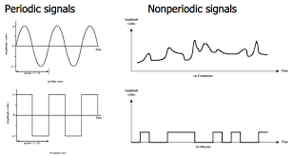
4.1 Periodic Signal
A periodic signal repeats itself after a fixed interval of time.
Example:
- sine wave
- clock pulse
Meaning:
The same pattern keeps repeating.

4.2 Non-Periodic Signal
A non-periodic signal does not repeat its pattern regularly.
Example:
- human speech
- random data transmission
Meaning:
The signal changes irregularly.

5. Important Terms Related to Signals
5.1 Amplitude
Amplitude is the maximum height of the signal from the reference level.
It shows the strength of the signal.
Example:
A higher voltage wave has greater amplitude.
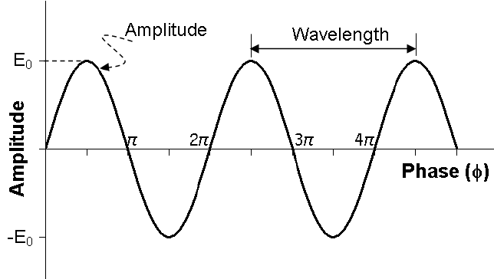
5.2 Frequency
Frequency is the number of complete cycles of a signal in one second.
Unit:
Hertz (Hz)
Example:
If a signal completes 50 cycles in one second, its frequency is 50 Hz.

5.3 Time Period
Time period is the time taken to complete one full cycle of a signal.
Formula:
T = 1 / f
Where:
- T = time period
- f = frequency
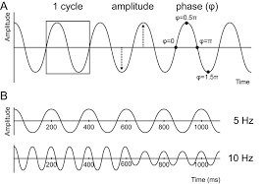
5.4 Phase
Phase tells the position of a waveform with respect to time.
It is used when comparing two signals.
6. Simple Example with Data
Suppose a signal completes 100 cycles in 1 second.
Then,
Frequency = 100 Hz
If the signal has a maximum height of 5 V, then:
Amplitude = 5 V
If time for one cycle is:
T = 1 / 100 = 0.01 second
So:
- Amplitude = 5 V
- Frequency = 100 Hz
- Time period = 0.01 sec

7. Real-Life Examples of Signals
Analog signal examples:
- microphone sound signal
- FM radio signal
- analog thermometer reading
Digital signal examples:
- computer data
- mobile message in binary
- digital watch output
- LAN communication

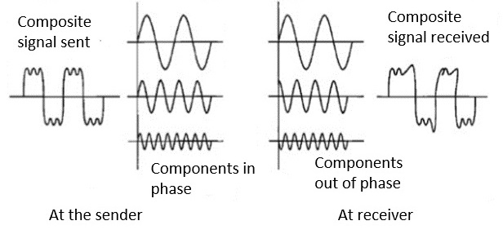
3.7 Transmission Impairment: Attenuation, Distortion and Noise

Introduction
When a signal travels from sender to receiver, it does not always remain perfect.
During transmission, the signal may become weak, changed, or mixed with unwanted signals.
These problems are called transmission impairments.
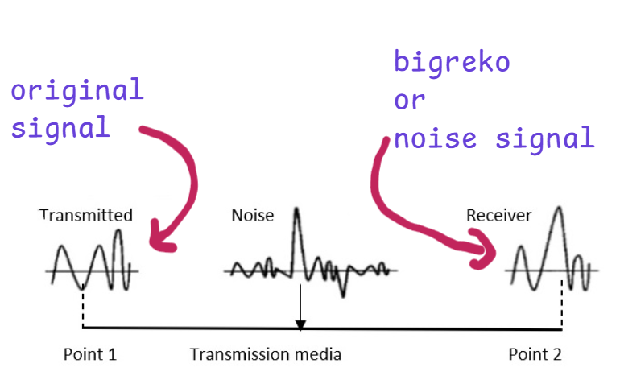
In simple words, transmission impairment means:
any condition that damages the quality of the signal during transmission.

The main types of transmission impairment are:
- Attenuation
- Distortion
- Noise

1. Attenuation
Attenuation means the loss of signal strength as the signal travels through the transmission medium.
When a signal moves over a long distance, its power gradually decreases.

Simple meaning
The signal becomes weaker and weaker with distance.
Example:
If a signal starts with strength 10 V at the sender and becomes 6 V at the receiver, then attenuation has occurred.
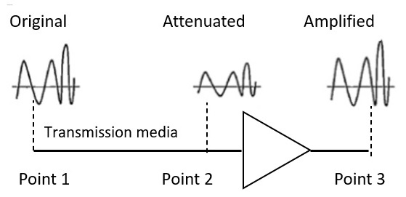

Causes:
- long cable length
- resistance of medium
- energy loss in transmission
Effects:
- weak signal at receiver
- difficult to detect data correctly
- communication errors may occur
Solution:
- use repeater
- use amplifier
- use better quality medium
Daily life analogy:
Suppose Ram speaks loudly from one side of a field.
As the sound travels farther, it becomes weaker.
This weakening is like attenuation.

2. Distortion
Distortion means a change in the shape or form of the signal during transmission.
It happens when different frequency components of a signal travel at different speeds.
So the received signal does not look exactly like the transmitted signal.
Simple meaning
The signal reaches the receiver, but its shape becomes different.
Example:
If a signal is sent as one waveform but arrives stretched, shifted, or bent, distortion has occurred.

Causes:
- different propagation speeds
- medium characteristics
- bandwidth limitations
Effects:
- data may be interpreted incorrectly
- signal quality becomes poor
Daily life analogy:
Imagine writing a straight line on paper, but after photocopying badly, it appears curved or stretched.
That change in original shape is like distortion.

3. Noise
Noise is any unwanted signal that gets mixed with the original signal during transmission.
Noise disturbs communication and reduces signal quality.
Simple meaning
Noise is extra unwanted disturbance added to the original signal.
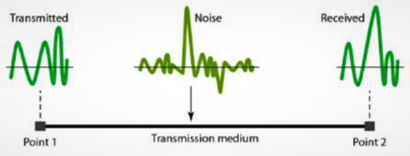
Example:
When talking on a phone, if you hear unwanted “shhh” or cracking sound, that is noise.
Causes:
- electrical interference
- thermal effect
- atmospheric disturbances
- nearby signals
- faulty equipment
Effects:
- wrong data may be received
- signal becomes unclear
- communication quality decreases

Types of Noise
1. Thermal Noise
Caused by random movement of electrons in a conductor.
Example:
Present in almost all electronic devices.

2. Induced Noise
Caused by external sources such as motors, power lines, or electrical devices.
Example:
Noise from nearby electric wire affecting communication cable.

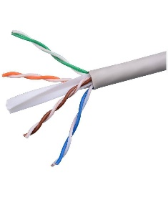
3. Crosstalk
Occurs when one signal interferes with another signal in nearby wires.
Example:
Two telephone lines affecting each other.
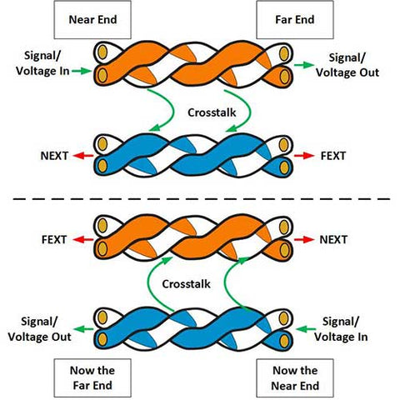
4. Impulse Noise
Sudden short-duration noise caused by lightning, switching, or faults.
Example:
A sudden spike in signal during storm.

3.8 Multiplexing: TDM, FDM and WDM

Introduction
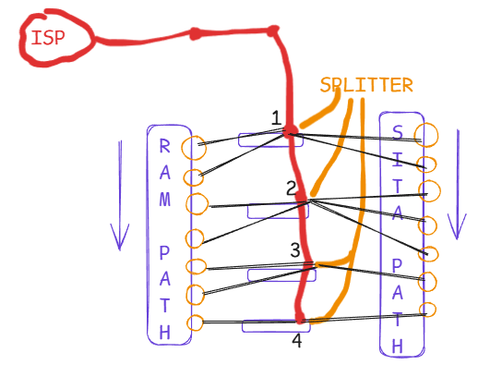
Multiplexing is a technique in which multiple signals or data streams are combined and transmitted through a single communication channel.
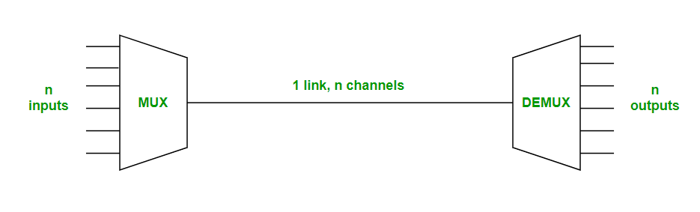
In simple words, multiplexing allows many users or many signals to share one medium.

At the sender side, signals are combined by a device called Multiplexer (MUX).
At the receiver side, signals are separated by a device called Demultiplexer (DEMUX).

Simple idea
Instead of using separate channels for every user, multiplexing uses one channel efficiently.

Why Multiplexing is Needed
Multiplexing is needed because:
- communication channels are expensive
- one channel can be shared by many users
- bandwidth can be used efficiently
- it reduces cost
- it increases channel utilization
Example:
Suppose 10 users want to send data.
Instead of using 10 separate lines, multiplexing allows them to share one line.

Basic Components of Multiplexing
1. Multiplexer (MUX)
Combines multiple input signals into one output signal.
2. Communication Channel
The combined signal travels through a single medium.
3. Demultiplexer (DEMUX)
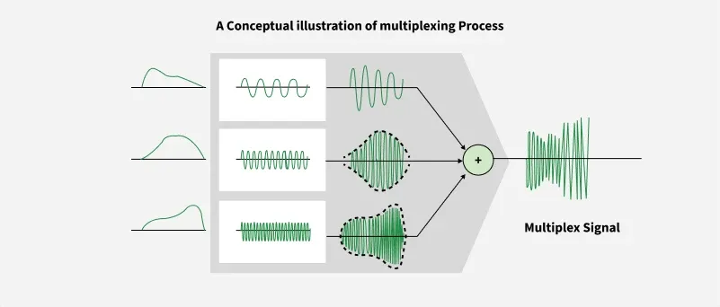
Separates the combined signal back into original signals at the receiver side.

Simple flow:
Input signals → MUX → Single channel → DEMUX → Original signals
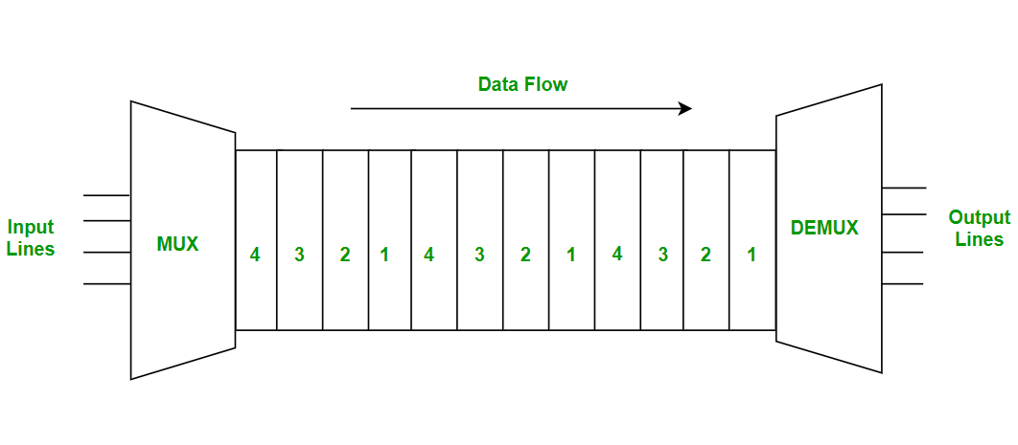
Types of Multiplexing
The main types are:
- TDM – Time Division Multiplexing
- FDM – Frequency Division Multiplexing
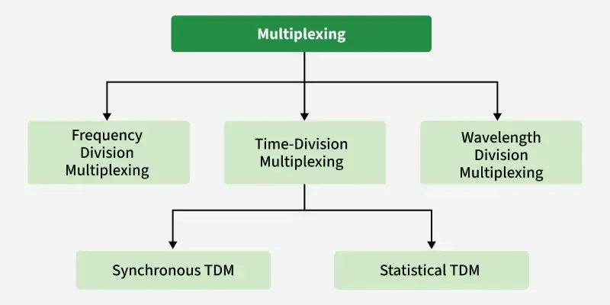
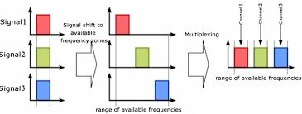
- WDM – Wavelength Division Multiplexing

1. TDM – Time Division Multiplexing
In Time Division Multiplexing (TDM), multiple signals share the same channel, but each signal gets a different time slot.
That means users do not send data at the same exact moment.
They send one after another in very small time intervals.
Simple meaning
One channel is shared by many users by dividing time.
Example:
Suppose 4 users share one line:
- user 1 sends in time slot 1
- user 2 sends in time slot 2
- user 3 sends in time slot 3
- user 4 sends in time slot 4
Then the cycle repeats again.

Daily life analogy:
Imagine one water tap and 4 people filling bottles:
- first person uses the tap for 10 seconds
- second person uses it for next 10 seconds
- third person after that
- fourth person after that
Everyone uses the same tap, but at different times.
This is like TDM.
Uses:
- digital telephony
- computer networks
- communication systems
Advantages:
- efficient for digital signals
- no frequency separation needed
- better use of full bandwidth during time slot
Disadvantages:
- synchronization required
- if one slot is empty, time may be wasted in simple TDM

2. FDM – Frequency Division Multiplexing
In Frequency Division Multiplexing (FDM), the available bandwidth is divided into different frequency bands, and each signal is assigned a separate frequency band.
All signals are transmitted at the same time, but on different frequencies.
Simple meaning
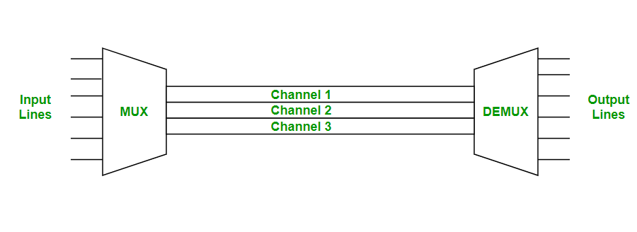
One channel is shared by many users by dividing frequency.

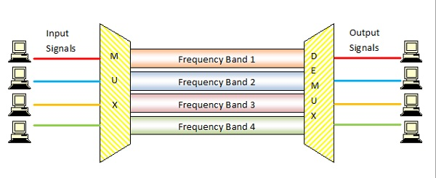
Example:
Different radio stations:
- Radio Nepal on one frequency
- another FM on another frequency
- another station on another frequency
All are transmitted at the same time, but each uses a different frequency.
Daily life analogy:
Imagine a road with several lanes:
- each vehicle uses its own lane
- all vehicles move at the same time
This is like FDM, where each signal gets its own frequency lane.
Uses:
- radio broadcasting
- television broadcasting
- cable communication
Advantages:
- signals can transmit simultaneously
- suitable for analog transmission
- continuous transmission possible
Disadvantages:
- guard bands are needed
- bandwidth may be wasted
- interference may occur if frequencies overlap

3. WDM – Wavelength Division Multiplexing
WDM is similar to FDM, but it is used in optical fiber communication.
In WDM, multiple optical signals are transmitted through the same fiber using different wavelengths of light.
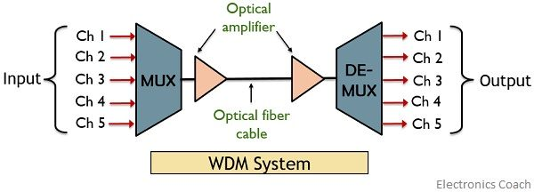
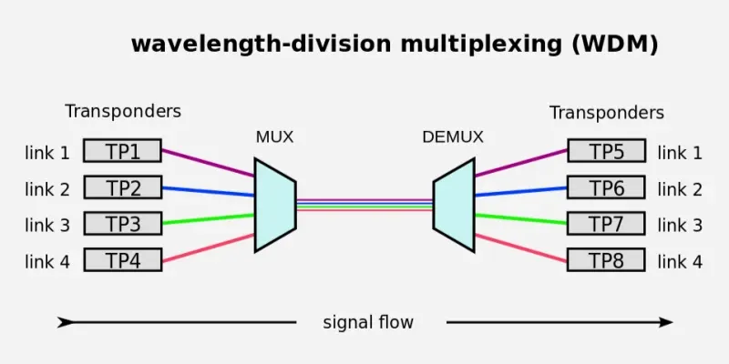
Simple meaning
One optical fiber carries many signals by using different light colors or wavelengths.
Example:
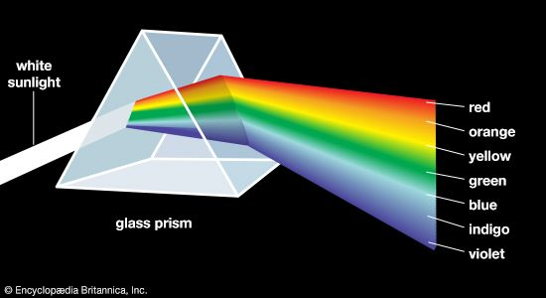
In fiber communication, one wavelength may carry internet data, another may carry voice, and another may carry video.
Daily life analogy:
Imagine white light passing through a prism and splitting into many colors.
Each color can carry separate information.
That idea is similar to WDM.
Uses:
- optical fiber networks
- internet backbone
- long-distance high-speed communication
Advantages:
- very high capacity
- efficient use of optical fiber
- supports many channels at once
Disadvantages:
- expensive equipment
- complex design
- used mainly in fiber optic systems

Comparison of TDM, FDM and WDM
Basis | TDM | FDM | WDM
Full form | Time Division Multiplexing | Frequency Division Multiplexing | Wavelength Division Multiplexing
Division based on | Time | Frequency | Light wavelength
Used mainly for | Digital signals | Analog signals | Optical fiber
Transmission | One after another | Simultaneously | Simultaneously
Example | Digital phone system | Radio stations | Fiber backbone

Simple Example for Understanding
Suppose 3 users want to send data through one channel.
In TDM:
- User 1 sends in first time slot
- User 2 sends in second time slot
- User 3 sends in third time slot
In FDM:
- User 1 gets frequency f1
- User 2 gets frequency f2
- User 3 gets frequency f3
All send at the same time.
In WDM:
- User 1 gets wavelength λ1
- User 2 gets wavelength λ2
- User 3 gets wavelength λ3
All send together through one optical fiber.

Small Numerical Style Example
Suppose one channel has total bandwidth of 12 kHz and 3 signals need 4 kHz each.
In FDM:
- Signal 1 = 4 kHz
- Signal 2 = 4 kHz
- Signal 3 = 4 kHz
Total required bandwidth:
4 + 4 + 4 = 12 kHz
So all 3 signals can be sent together using FDM

=================================================================================

Numerical on TDM, FDM, and WDM

1. Numerical on TDM
Question 1
A TDM system has 4 input channels. Each channel is given 1 time slot in one frame.
If each time slot carries 8 bits, find:
- Total number of bits in one frame
- If 1000 frames are sent per second, find the total bit rate
Solution
Given:
- Number of channels = 4
- Bits per slot = 8
- Frames per second = 1000
1. Bits in one frame
Each frame contains one slot from each channel.
So,
Bits per frame = Number of channels × Bits per slot
Bits per frame = 4 × 8 = 32 bits
2. Bit rate
Bit rate = Bits per frame × Frames per second
Bit rate = 32 × 1000 = 32000 bps
Answer
- Bits in one frame = 32 bits
- Total bit rate = 32000 bps or 32 kbps

Question 2
In a TDM system, 8 devices share one channel.
Each device sends 10 bits in one frame.
Find the number of bits in one frame.
Solution
Given:
- Number of devices = 8
- Bits per device per frame = 10
Bits per frame = 8 × 10 = 80 bits
Answer
Bits in one frame = 80 bits

2. Numerical on FDM
Question 1
An FDM system is designed to combine 3 voice channels, each requiring 4 kHz bandwidth.
Find the total required bandwidth if guard bands are ignored.
Solution
Given:
- Number of channels = 3
- Bandwidth per channel = 4 kHz
Total bandwidth = Number of channels × Bandwidth per channel
Total bandwidth = 3 × 4 = 12 kHz
Answer
Total required bandwidth = 12 kHz
Question 2
A communication system uses FDM to combine 5 channels.
Each channel requires 6 kHz bandwidth.
There is a 1 kHz guard band between adjacent channels.
Find the total bandwidth required.
Solution
Given:
- Number of channels = 5
- Bandwidth per channel = 6 kHz
- Guard band = 1 kHz
Step 1: Total channel bandwidth
5 × 6 = 30 kHz
Step 2: Number of guard bands
Between 5 channels, guard bands = 4
Step 3: Total guard band bandwidth
4 × 1 = 4 kHz
Step 4: Total bandwidth
Total bandwidth = 30 + 4 = 34 kHz
Answer
Total required bandwidth = 34 kHz

3. Numerical on WDM
Question 1
A WDM system uses 4 optical channels on one fiber.
If each channel carries 2.5 Gbps, find the total data carrying capacity of the fiber.
Solution
Given:
- Number of channels = 4
- Capacity per channel = 2.5 Gbps
Total capacity = Number of channels × Capacity per channel
Total capacity = 4 × 2.5 = 10 Gbps
Answer
Total fiber capacity = 10 Gbps

Question 2
A WDM optical fiber carries 8 wavelengths, and each wavelength carries 10 Gbps.
Find the total transmission capacity.
Solution
Given:
- Number of wavelengths = 8
- Capacity per wavelength = 10 Gbps
Total capacity = 8 × 10 = 80 Gbps
Answer
Total transmission capacity = 80 Gbps

Mixed Short Practice Set
TDM Practice
A TDM frame has 6 channels, each contributing 7 bits.
Find bits per frame.
Solution
Bits per frame = 6 × 7 = 42 bits
Answer
42 bits

FDM Practice
An FDM system combines 4 channels, each of 5 kHz.
Find total bandwidth without guard bands.
Solution
Total bandwidth = 4 × 5 = 20 kHz
Answer
20 kHz

WDM Practice
A WDM system has 16 wavelengths, each carrying 5 Gbps.
Find total capacity.
Solution
Total capacity = 16 × 5 = 80 Gbps
Answer
80 Gbps

Short Formulas
TDM
Bits per frame = Number of channels × Bits per slot
Bit rate = Bits per frame × Frames per second

FDM
Total bandwidth = Sum of channel bandwidths + Guard bands
If equal bandwidth:
Total bandwidth = n × channel bandwidth + guard bands

WDM
Total capacity = Number of wavelengths × Capacity per wavelength

3.9 Switching: Circuit Switching, Message Switching, Packet Switching, Virtual Circuit Switching
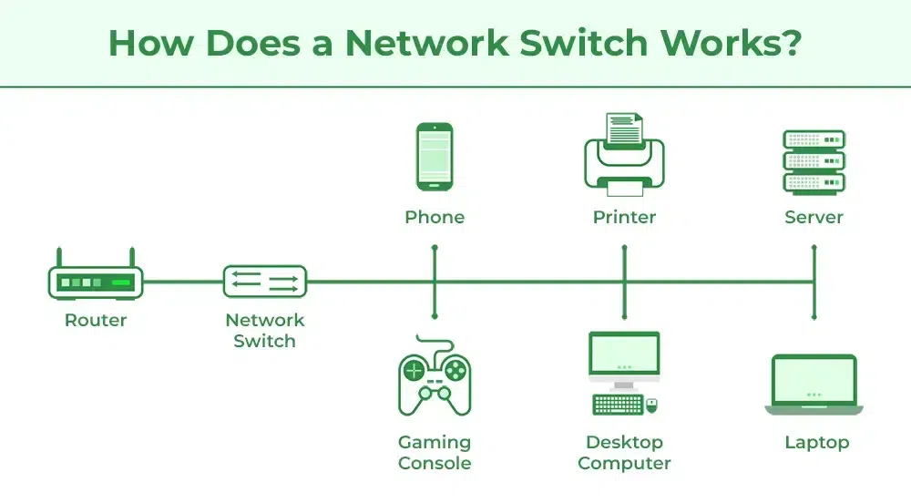
Network Switching is a specific type of switching used in computer networks. It is about transferring data packets from one device (node) to another across a network.
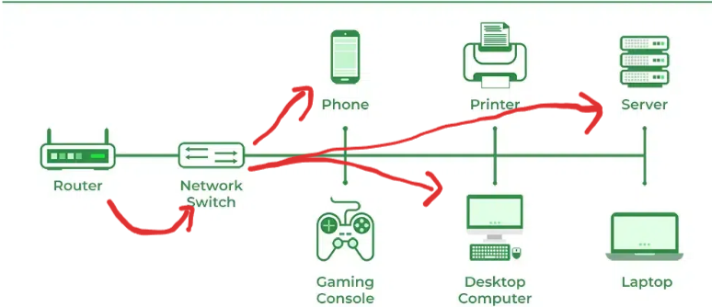

Introduction
Switching is the process of transferring data from a source to a destination through a network.
In a communication network, many devices are connected. So the network must decide:
- how data should travel
- which path should be used
- how sender and receiver should communicate
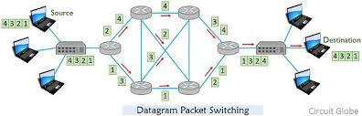
This process is called switching.

Simple meaning
Switching means choosing and using a path to send data from one device to another.
Example:
When you send a message from your mobile phone to another person, the network chooses a path to deliver that message.

Why Switching is Needed
Switching is needed because:
- every user cannot have a separate direct line to every other user
- network resources must be shared
- data must reach the correct destination
- communication must be efficient and organized

Types of Switching
The main types of switching are:
- Circuit Switching
- Message Switching
- Packet Switching
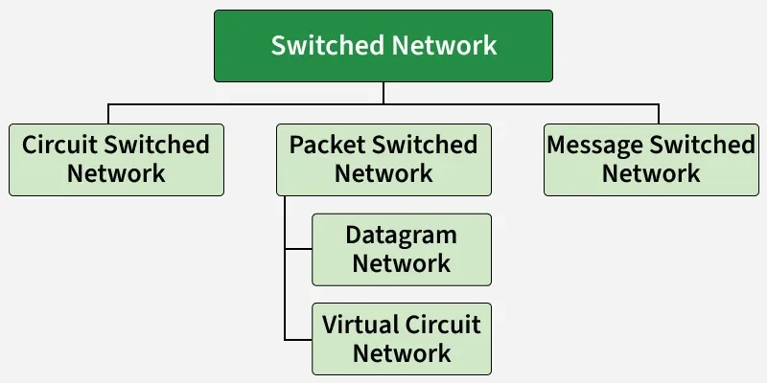
- Virtual Circuit Switching

1. Circuit Switching
In circuit switching, a dedicated communication path is established between sender and receiver before data transfer begins.
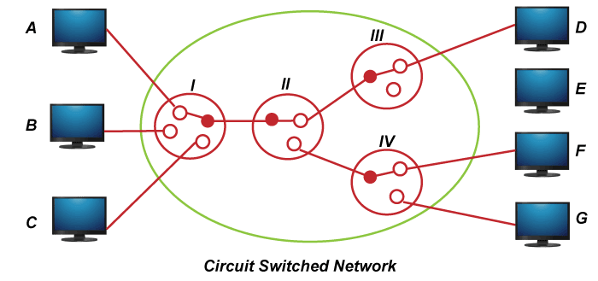
The path remains reserved for the whole communication session.
Simple meaning
First a path is created, then communication happens on that fixed path.
Example:
Traditional telephone system
When two people make a phone call, a dedicated path is established between them and remains active until the call ends.

Phases of Circuit Switching
There are usually three phases:
1. Setup Phase
The path is established.
2. Data Transfer Phase
Actual communication takes place.
3. Disconnect Phase
The path is released after communication ends.

Advantages of Circuit Switching
- dedicated path available
- continuous transmission
- good for voice communication
- no need to decide path for each data unit

Disadvantages of Circuit Switching
- channel remains reserved even when no data is being sent
- bandwidth may be wasted
- setup time is required
- not efficient for bursty data communication

Daily Life Analogy
Imagine reserving an entire road lane only for Ram’s car from Butwal to Kathmandu.
Even if Ram stops for tea, the lane stays reserved for him.
That is like circuit switching.

2. Message Switching
In message switching, the entire message is treated as one unit and sent from one node to another.
Each intermediate node:
- receives the whole message
- stores it
- then forwards it to the next node
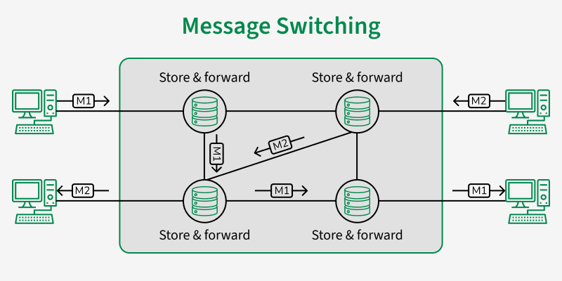
This is called store-and-forward switching.
Simple meaning
The complete message is stored at each stop before being sent forward.
Example:
Telegram-like communication system or older communication methods.
Advantages of Message Switching
- no dedicated path needed
- efficient channel use
- messages can be routed dynamically

Disadvantages of Message Switching
- high delay
- not suitable for real-time communication
- large storage needed at intermediate nodes

Daily Life Analogy
Suppose Sita sends a full parcel through a courier office.
The parcel reaches one office, stays there for some time, then goes to the next office, and finally reaches the destination.
That is like message switching.

3. Packet Switching
In packet switching, the message is divided into small units called packets.
Each packet is sent separately through the network.
Packets may take:
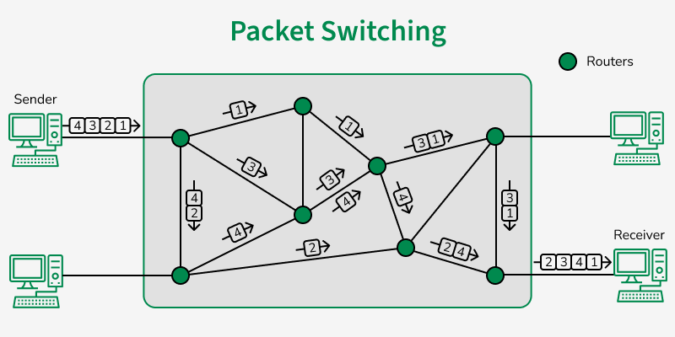
- the same path
- or different paths
At the destination, all packets are reassembled to form the original message.
Simple meaning
Big message is broken into smaller packets and sent individually.
Example:
Internet communication
When you browse a website or send an email, the data is broken into packets.

Advantages of Packet Switching
- efficient use of bandwidth
- suitable for data communication
- no dedicated path needed
- supports many users at the same time
- reliable and flexible

Disadvantages of Packet Switching
- packets may arrive out of order
- delay may vary
- packets may be lost and need retransmission

Daily Life Analogy
Suppose Ram wants to send a book to Hari, but instead of sending it as one big parcel, he tears it into chapters, packs each chapter separately, and sends them one by one. Hari later combines them in correct order.
That is like packet switching.

4. Virtual Circuit Switching
Virtual circuit switching is a type of packet switching in which a logical path is established before packets are sent.

All packets follow the same logical route, but the network does not reserve a dedicated physical path like circuit switching.

Simple meaning
A route is decided first, and then all packets follow that same route.
Example:
Frame relay, ATM, and some WAN technologies

Advantages of Virtual Circuit Switching
- packets arrive in order
- easier management than pure packet switching
- better than message switching for many applications

Disadvantages of Virtual Circuit Switching
- setup phase required
- if path fails, communication is affected
- less flexible than pure packet switching

Daily Life Analogy
Imagine a courier company deciding one fixed route for all of Ram’s parcels before delivery starts.
Each small parcel follows that same decided route.
That is like virtual circuit switching.

Comparison of Switching Techniques
Switching Type | Path | Data Unit | Delay | Best Use
Circuit Switching | Dedicated physical path | Continuous stream | Low after setup | Telephone/voice
Message Switching | No dedicated path | Entire message | High | Non-real-time
Packet Switching | No dedicated path | Packets | Variable | Internet/data
Virtual Circuit Switching | Logical fixed path | Packets | Moderate | WAN/data networks

Numerical 1: Circuit Switching Case  A college in Butwal has connected its administration office with the examination section through a circuit-switched communication system. During an important result-processing day, Ram from the administration office needs to talk continuously with Sita in the examination section for 12 minutes. The communication line provides a dedicated data path of 64 kbps for the whole session. Once the circuit is established, the entire bandwidth remains reserved until the conversation ends, even if the users remain silent for some time. The network administrator wants to calculate how much total data-carrying capacity was reserved by the network during the full call duration. Assume the reserved channel remains active for the complete 12 minutes.  Given:  - Bandwidth = 64 kbps  - Time = 12 minutes  Solution:  Convert time into seconds:  12 minutes = 12 × 60 = 720 seconds  Now,  Total data capacity reserved = Bandwidth × Time  = 64 kbps × 720 s  = 64000 bps × 720  = 46,080,000 bits  Convert into kilobits:  46,080,000 / 1000 = 46,080 kb  Convert into megabits:  46,080,000 / 1,000,000 = 46.08 Mb  Answer:  The total data-carrying capacity reserved during the 12-minute circuit-switched session is:  46,080,000 bits  or  46,080 kb  or  46.08 Mb  Conclusion:  In circuit switching, the full channel remains reserved for the complete duration, so even if no actual data is sent at some moments, the capacity is still occupied. | Numerical 2: Message Switching Case  A district office in Nepal wants to send a large digital notice file from one branch to another using a message switching network. The full message size is 900 KB. The message must pass through 3 intermediate switching nodes before reaching the final destination. In message switching, the entire message is first received, stored, and then forwarded at each node. Assume that the transmission speed of every link is 300 KB per second, and ignore propagation delay. The office wants to know the total time needed for the whole message to reach the destination. Since the message must pass through 3 intermediate nodes, it will travel over 4 links total: source to node 1, node 1 to node 2, node 2 to node 3, and node 3 to destination.  Given:  - Message size = 900 KB  - Transmission speed = 300 KB/s  - Number of links = 4  Solution:  Time to transmit the whole message over one link:  Time = Message size / Transmission speed  = 900 KB / 300 KB/s = 3 seconds  Since message switching uses store-and-forward, the full message must be sent completely over each link.  Total time:  Total time = 3 seconds × 4 links = 12 seconds  Answer:  The total time needed to send the full message to the destination is: 12 seconds  Conclusion:  In message switching, the whole message is stored at each intermediate node before forwarding, so delay becomes high. That is why message switching is not suitable for real-time communication.
Numerical 3: Packet Switching Case  Hari is sending a project report from his college computer to the central server using a packet switching network. The total report size is 1200 KB. The network divides this report into packets of 200 KB each. The transmission speed of the link is 400 KB per second. The path contains 2 intermediate routers, which means the packets pass through 3 links total from source to destination. Assume store-and-forward packet switching, and ignore propagation delay. Hari wants to know two things:  - how many packets will be created, and  - how much time will be required for the first packet to reach the destination and for the entire file to be delivered, assuming pipelining is used.  Given:  - Total file size = 1200 KB  - Packet size = 200 KB  - Transmission speed = 400 KB/s  - Number of links = 3  Solution:  Step 1: Number of packets  Number of packets = Total file size / Packet size = 1200 / 200 = 6 packets  Step 2: Time to transmit one packet on one link  Time = Packet size / Transmission speed = 200 / 400 = 0.5 second  Step 3: Time for first packet to reach destination  The first packet must cross 3 links:  First packet arrival time = 3 × 0.5 = 1.5 seconds  Step 4: Time for all packets to arrive  After the first packet arrives, the remaining packets follow in pipelined form.  For n packets over m links:  Total time = (m + n - 1) × transmission time per packet  Here:  - m = 3 n = 6  - transmission time per packet = 0.5 s  So,  Total time = (3 + 6 - 1) × 0.5 = 8 × 0.5 = 4 seconds  Answer:  - Number of packets = 6  - First packet reaches destination in 1.5 seconds  - Entire file reaches destination in 4 seconds  Conclusion:  Packet switching is faster than message switching for large data because packets move in pipeline form, allowing efficient use of the network. | Question 1: Circuit Switching  A college in Butwal has connected its administration office with the examination section through a circuit-switched communication system. During result preparation, Ram from the administration office needs to communicate continuously with Sita in the examination section for 15 minutes. The communication channel provides a dedicated bandwidth of 64 kbps for the entire session. Once the circuit is established, the full bandwidth remains reserved until the communication ends, even if no actual data is being sent during some moments. Calculate the total data-carrying capacity reserved by the network during the full communication period.  Question 2: Message Switching  A government office wants to send a digital notice file of size 1200 KB from one branch office to another using a message switching network. The message must pass through 2 intermediate switching nodes before reaching the final destination. The transmission speed of each link is 300 KB per second. In message switching, the complete message is received, stored, and then forwarded at each intermediate node. Ignoring propagation delay, calculate the total time required for the complete message to reach the destination.  Question 3: Packet Switching  Hari is sending a project report of size 1000 KB from his college computer to the central server using a packet switching network. The report is divided into packets of 250 KB each. The transmission speed of each link is 500 KB per second, and the path contains 2 intermediate routers, making a total of 3 links from source to destination. Assume store-and-forward packet switching and ignore propagation delay. Calculate:  - the number of packets created, and  - the total time required for the entire report to reach the destination using pipelining.

3.10 Network Performance: Bandwidth, Throughput, Latency, Bandwidth-Delay Product, Jitter
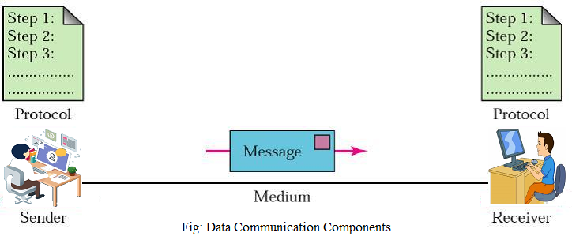
Network performance means how well a network works while sending and receiving data.
A good network should:
- send data fast
- deliver data correctly
- have less delay
- have stable communication

To measure network performance, some important terms are used:
- Bandwidth Throughput Latency Bandwidth-Delay Product Jitter

1. Bandwidth
Bandwidth is the maximum capacity of a communication channel to carry data.
In simple words, it tells the maximum amount of data that can be sent through a network in one second.
Unit:
- bps = bits per second
- kbps, Mbps, Gbps

Example:
If a network link supports 100 Mbps, then its maximum capacity is 100 megabits per second.
Simple analogy:
Think of bandwidth like the width of a water pipe.
- wider pipe = more water can flow
- larger bandwidth = more data can flow

Important point:
Bandwidth shows the maximum possible rate, not the actual rate.

2. Throughput
Throughput is the actual amount of data successfully transferred through the network in a given time.
It is the real performance of the network.
Unit:
- bps
- kbps
- Mbps
Example:
A network may have bandwidth of 100 Mbps, but because of traffic, errors, and overhead, actual data transfer may be only 75 Mbps.
Then:
- Bandwidth = 100 Mbps
- Throughput = 75 Mbps
Simple analogy:
If a road can support 100 cars per minute, but because of traffic only 70 cars actually pass, then:
- road capacity = bandwidth
- actual cars passed = throughput
Important point:
Throughput is usually less than bandwidth.

3. Latency
Latency is the total time taken by data to travel from source to destination.
It is also called delay.
Unit:
- milliseconds (ms)
- seconds
Example:
If a packet takes 20 ms to travel from one computer to another, then the latency is 20 ms.
Causes of latency:
- propagation delay
- transmission delay
- processing delay
- queuing delay
Simple analogy:
Suppose you send a letter today and it reaches tomorrow.
The time taken is like latency.
Important point:
Lower latency means better performance, especially for:
- gaming
- video calls
- online classes
- live streaming

4. Bandwidth-Delay Product
The Bandwidth-Delay Product is the amount of data that can be “in transit” in the network at one time.
It is calculated by:
Formula:
Bandwidth-Delay Product = Bandwidth × Delay

Meaning:
It shows how much data the network can hold while data is moving from sender to receiver.
Example:
If:
- Bandwidth = 1 Mbps
- Delay = 0.1 second
Then:
Bandwidth-Delay Product = 1,000,000 × 0.1 = 100,000 bits
This means 100,000 bits can be present in the network at one time.
Simple analogy:
Think of a pipe carrying water.
- bandwidth = how much water per second can flow
- delay = how long water takes to reach the end
- bandwidth-delay product = how much water is inside the pipe

5. Jitter
Jitter is the variation in packet arrival time.
In simple words, if packets do not arrive at equal intervals, jitter occurs.
Example:
Suppose 3 packets arrive as:
- Packet 1 = 10 ms
- Packet 2 = 20 ms
- Packet 3 = 12 ms
The arrival time is not consistent, so jitter is present.
Effects of jitter:
- poor voice quality
- broken video
- interruption in real-time communication
Used in:
- VoIP
- video conferencing
- online gaming
- streaming
Simple analogy:
Suppose a bus is expected every 10 minutes, but comes after 8 minutes, then 14 minutes, then 9 minutes.
This variation is like jitter.

Comparison of Terms
Term | Meaning | Unit
Bandwidth | Maximum capacity of network | bps
Throughput | Actual data transfer rate | bps
Latency | Time taken for data to travel | ms / sec
Bandwidth-Delay Product | Data present in network during transmission | bits
Jitter | Variation in packet arrival time | ms

Simple Example with Data
Suppose a network has:
- Bandwidth = 50 Mbps
- Throughput = 35 Mbps
- Latency = 30 ms
This means:
- maximum capacity is 50 Mbps
- actual transferred data is 35 Mbps
- one packet takes 30 ms to reach destination
If packet arrival times are:
- 30 ms
- 40 ms
- 28 ms
Then there is jitter.

Small Numerical Examples
Numerical 1: Throughput
A network link has bandwidth 100 Mbps, but actual transfer is only 80 Mbps.
Answer:
- Bandwidth = 100 Mbps
- Throughput = 80 Mbps

Numerical 2: Latency
A packet is sent at 2:00:00 and received at 2:00:00.050
Answer:
Latency = 50 ms

Numerical 3: Bandwidth-Delay Product
Bandwidth = 2 Mbps
Delay = 0.2 sec
Bandwidth-Delay Product = 2,000,000 × 0.2 = 400,000 bits
Answer:
400,000 bits

Why These Terms Matter
These network performance terms are important because they help us:
- evaluate network quality
- compare networks
- improve speed and reliability
- troubleshoot problems
- design better communication systems

